https://nkdairyproducts.blogspot.com/2023/10/nk-dairy-products.html

[NK Dairy Products](https://nkdairyproducts.blogspot.com/?m=1)

**NK Dairy Products **

[October 11, 2023](https://nkdairyproducts.blogspot.com/2023/10/nk-dairy-products.html?m=1)

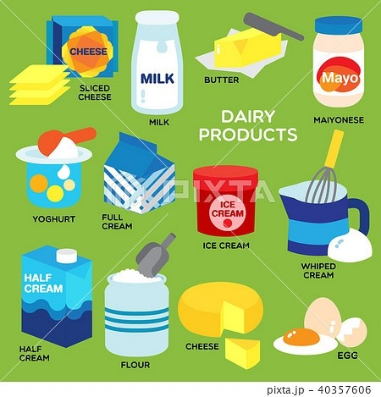

**Dairy products** or **milk products**, also known as **lacticinia**, are [food products](https://en.m.wikipedia.org/wiki/Food_product) made from (or containing) [milk](https://en.m.wikipedia.org/wiki/Milk).[[a]](https://en.m.wikipedia.org/wiki/Dairy_product#cite_note-1)[[1]](https://en.m.wikipedia.org/wiki/Dairy_product#cite_note-2) The most common dairy animals are [cow](https://en.m.wikipedia.org/wiki/Cow), [water buffalo](https://en.m.wikipedia.org/wiki/Water_buffalo), [nanny goat](https://en.m.wikipedia.org/wiki/Dairy_goat), [and ewe. Dairy products include common grocery store food items in the Western](https://en.m.wikipedia.org/wiki/Western_world)

[world such as](https://en.m.wikipedia.org/wiki/Western_world) [yogurt](https://en.m.wikipedia.org/wiki/Yogurt)[,](https://en.m.wikipedia.org/wiki/Western_world) [cheese](https://en.m.wikipedia.org/wiki/Cheese)[,](https://en.m.wikipedia.org/wiki/Western_world) [milk](https://en.m.wikipedia.org/wiki/Milk) [and](https://en.m.wikipedia.org/wiki/Western_world) [butter](https://en.m.wikipedia.org/wiki/Butter)[.](https://en.m.wikipedia.org/wiki/Western_world)[[2]](https://en.m.wikipedia.org/wiki/Dairy_product#cite_note-3)[[3]](https://en.m.wikipedia.org/wiki/Dairy_product#cite_note-4) [A facility that produces dairy pr](https://en.m.wikipedia.org/wiki/Western_world)oducts is known as a *[dairy](https://en.m.wikipedia.org/wiki/Dairy)*.[[b]](https://en.m.wikipedia.org/wiki/Dairy_product#cite_note-5)[[4]](https://en.m.wikipedia.org/wiki/Dairy_product#cite_note-6) Dairy products are consumed worldwide to varying degrees

(see [consumption patterns worldwide](https://en.m.wikipedia.org/wiki/Dairy_product#Consumption_patterns_worldwide)).[[5]](https://en.m.wikipedia.org/wiki/Dairy_product#cite_note-fao-7) Some people avoid some or all dairy products either because of [lactose intolerance](https://en.m.wikipedia.org/wiki/Lactose_intolerance), [veganism](https://en.m.wikipedia.org/wiki/Veganism), or other health reasons or beliefs.

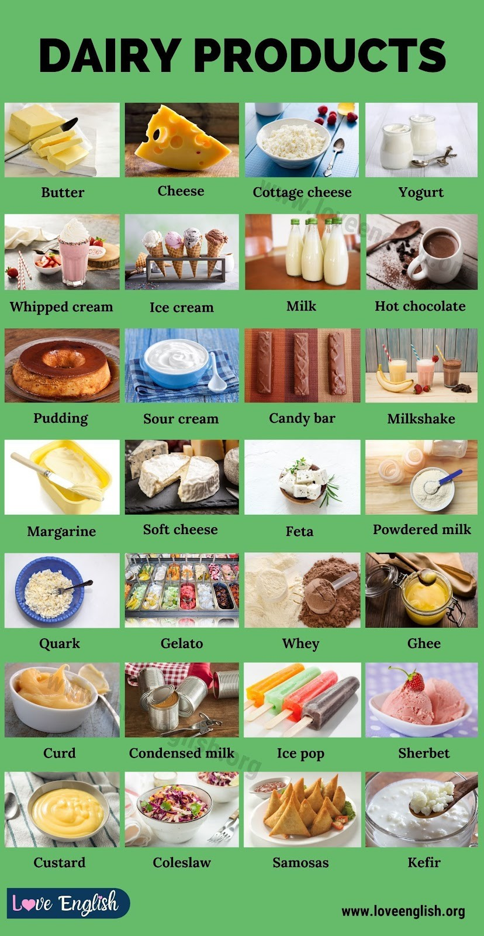

# T ypes of dairy product

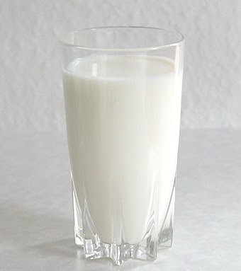

All dairy products derive from milk.

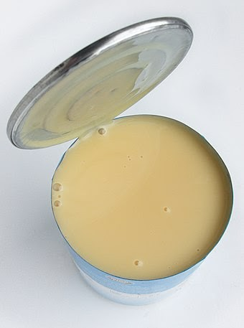

[Milk](https://en.m.wikipedia.org/wiki/Milk) is produced after optional [homogenization](https://en.m.wikipedia.org/wiki/Homogenization_(chemistry)) or [pasteurization](https://en.m.wikipedia.org/wiki/Pasteurization), in several grades after [standardization of the fat level, and possible addition of the bacteria](https://en.m.wikipedia.org/wiki/Streptococcus_lactis) *[Streptococcus lactis](https://en.m.wikipedia.org/wiki/Streptococcus_lactis)* [and](https://en.m.wikipedia.org/wiki/Streptococcus_lactis) *[Leuconostoc citrovorum](https://en.m.wikipedia.org/wiki/Leuconostoc_citrovorum)*[. Milk can be broken down into several different](https://en.m.wikipedia.org/wiki/Streptococcus_lactis)

categories based on type of product produced, including cream, butter, cheese, infant formula, and yogurt.

Milk varies in fat content. [Skim milk](https://en.m.wikipedia.org/wiki/Skim_milk) is milk with zero fat, while [whole milk](https://en.m.wikipedia.org/wiki/Whole_milk) products contain fat.

Milk is an ingredient in many confectioneries. Milk can be added to chocolate to produce [milk chocolate](https://en.m.wikipedia.org/wiki/Milk_chocolate).

[Scalded milk](https://en.m.wikipedia.org/wiki/Scalded_milk)

[Condensed milk](https://en.m.wikipedia.org/wiki/Condensed_milk), milk which has been concentrated by evaporation, with sugar added for reduced process time and longer life in an opened can

[Evaporated milk](https://en.m.wikipedia.org/wiki/Evaporated_milk), (less concentrated than condensed) milk without [added sugar](https://en.m.wikipedia.org/wiki/Added_sugar) [Baked milk](https://en.m.wikipedia.org/wiki/Baked_milk) is milk simmered on low heat for long time which results in

mild [caramelization](https://en.m.wikipedia.org/wiki/Caramelization). Particularly popular in [Eastern Europe](https://en.m.wikipedia.org/wiki/Eastern_Europe). [Dulce de leche](https://en.m.wikipedia.org/wiki/Dulce_de_leche)

[Malai](https://en.m.wikipedia.org/wiki/Malai)

[Powdered milk](https://en.m.wikipedia.org/wiki/Powdered_milk) (or milk powder), produced by removing the water from (usually skim) milk

[Khoa, milk which has been completely concentrated by evaporation, used in Indian cuisine](https://en.m.wikipedia.org/wiki/Indian_cuisine)

[Infant formula](https://en.m.wikipedia.org/wiki/Infant_formula), dried milk powder with speciﬁc additives for feeding human infants High milk-fat and nutritional products (for infant formulas)

[Whey](https://en.m.wikipedia.org/wiki/Whey), the liquid drained from curds and used for further processing or as a livestock feed

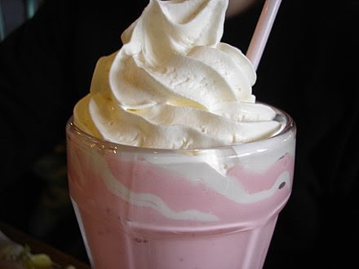[Buttermilk](https://en.m.wikipedia.org/wiki/Buttermilk), the liquid left over after producing butter from cream, often dried as livestock.

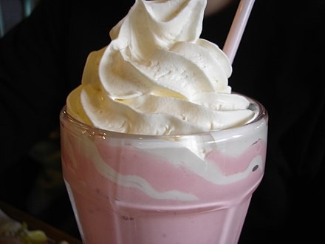

Whipped cream

[Cream](https://en.m.wikipedia.org/wiki/Cream) and fermented cream

Single cream, double cream and [whipped cream](https://en.m.wikipedia.org/wiki/Whipped_cream)

[Clotted cream](https://en.m.wikipedia.org/wiki/Clotted_cream), thick, spoonable cream made by heating milk [Kaymak](https://en.m.wikipedia.org/wiki/Kaymak)

[Sour cream](https://en.m.wikipedia.org/wiki/Sour_cream)

[Smetana](https://en.m.wikipedia.org/wiki/Smetana_(dairy_product)), Central and Eastern European variety of sour cream [Crème fraîche](https://en.m.wikipedia.org/wiki/Cr%C3%A8me_fra%C3%AEche), slightly fermented cream

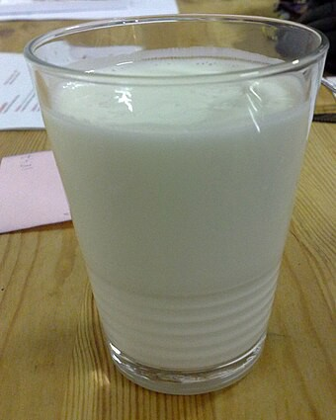

￼ [Keﬁr](https://en.m.wikipedia.org/wiki/Kefir) is a fermented [probiotic](https://en.m.wikipedia.org/wiki/Probiotic) dairy[Fermented milk products](https://en.m.wikipedia.org/wiki/Fermented_milk_products) include: [Soured milk](https://en.m.wikipedia.org/wiki/Soured_milk) obtained by fermentation with [mesophilic bacteria](https://en.m.wikipedia.org/wiki/Mesophile), mainly *[Lactococcus lactis](https://en.m.wikipedia.org/wiki/Lactococcus_lactis)* and other bacterial cultures and yeasts [Soured cream](https://en.m.wikipedia.org/wiki/Soured_cream) and [crème fraîche](https://en.m.wikipedia.org/wiki/Cr%C3%A8me_fra%C3%AEche)

[Cultured buttermilk](https://en.m.wikipedia.org/wiki/Buttermilk) resembling buttermilk, but uses different yeast and bacterial cultures

[Clabber](https://en.m.wikipedia.org/wiki/Clabber_(food)), milk naturally fermented to a yogurt-like state [Filmjölk](https://en.m.wikipedia.org/wiki/Filmj%C3%B6lk)

[Ymer](https://en.m.wikipedia.org/wiki/Ymer_(dairy_product)) [Viili](https://en.m.wikipedia.org/wiki/Viili)

[Keﬁr](https://en.m.wikipedia.org/wiki/Kefir), fermented milk drink from the [Northern Caucasus](https://en.m.wikipedia.org/wiki/Northern_Caucasus) [Kumis](https://en.m.wikipedia.org/wiki/Kumis), fermented mares' milk popular in [Central Asia](https://en.m.wikipedia.org/wiki/Central_Asia)

[Amasi](https://en.m.wikipedia.org/wiki/Amasi)

Ice cream

Ice cream, slowly frozen cream, milk, ﬂavors and emulsifying additives (dairy ice cream)

Gelato, slowly frozen milk and water, lesser fat than ice cream Ice milk, low-fat version of ice cream

Frozen custard

Frozen yogurt, yogurt with emulsiﬁers Casein[Mursik](https://en.m.wikipedia.org/wiki/Mursik)

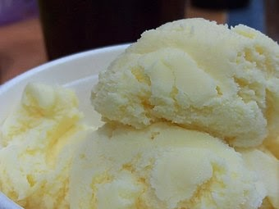



[#dairy #dairy products # Tamilnadu # perambalur # all over india](https://nkdairyproducts.blogspot.com/search/label/%23dairy %23dairy products %23 Tamilnadu %23 perambalur %23 all over india?m=1)

To leave a comment, click the button below to sign in with Blogger.

SIGN IN WITH BLOGGER

**Popular posts from this blog**

**[dairy products](https://nkdairyproducts.blogspot.com/2023/10/dairy-products.html?m=1)**

*[October 11, 2023](https://nkdairyproducts.blogspot.com/2023/10/dairy-products.html?m=1)*

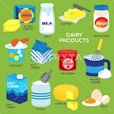Dairy products or milk products , also known as lacticinia , are food products made from (or containing) milk . [a] [1] The most common

dairy animals are cow , water buffalo , nanny goat , and e […](https://nkdairyproducts.blogspot.com/2023/10/dairy-products.html?m=1)

[we . Dairy](https://nkdairyproducts.blogspot.com/2023/10/dairy-products.html?m=1)

# [READ MORE](https://nkdairyproducts.blogspot.com/2023/10/dairy-products.html?m=1)

[Powered by Blogger](https://www.blogger.com/)

Theme images by [Michael Elkan](http://www.offset.com/photos/394244)



**[NK DAIRY PRODUCTS](https://www.blogger.com/profile/09292798512852621032)**

[VISIT PROFILE](https://www.blogger.com/profile/09292798512852621032)

**Archive Labels**

[Report Abuse](https://www.blogger.com/go/report-abuse)